Cognos Analytics Consumer User Guide –
An Introduction to Navigation in Cognos Analytics 11.2.0

COGNOS Analytics

May 2022

For additional information regarding Cognos, policies and access, or modifications to the ODS, please create a Cherwell ticket at https://tech.wayne.edu/forms/administrative and select Reporting and Analytics
For technical assistance, contact the Help Desk at helpdesk@wayne.edu or (313) 577-HELP.

Contents
➢ INTRODUCTION 2
➢ COGNOS OVERVIEW 2
A Brief Introduction to Cognos Roles 2
A Bit about Cognos Data Sources 3
➢ ACCESSING COGNOS 3
➢ A DEEPER DIVE INTO THE COGNOS WELCOME PORTAL 6
➢ GETTING TO YOUR REPORTS 8
➢ SEARCH 8
➢ TEAM CONTENT 12
➢ MY CONTENT 13
➢ RECENT REPORTS 14
➢ RUNNING REPORTS 16
➢ CREATE REPORT VIEWS 20
➢ SUBSCRIBING AND SCHEDULING REPORTS 28
➢ SCHEDULE MANAGEMENT 36
➢ NAVIGATING WSU MAIN BI PORTAL 38

INTRODUCTION

The purpose of this training guide is to familiarize you with the basic features of Cognos Analytics.

- What is Cognos?

- Cognos is a business intelligence and performance management software suite sold by IBM. The software suite is designed to enable non-technical personnel in large enterprises to extract organizational data, analyze them and then produce reports that help leaders make informed decisions.

- Cognos is a Web-based, integrated business intelligence suite that provides a powerful toolset for mining, analyzing, dashboarding and monitoring of events, data and metrics. It allows an organization to become more data and analytics driven, giving it the capacity to predict or find market trends and then react to them with informed decisions.

COGNOS OVERVIEW
High Level look at Cognos Analytics Interface Components
- Welcome Page is the Web page for Cognos Analytics.
It is the starting point for all functions provided in the suite where you can:
- Access quick launch items: Upload and present data
- Get Started with learning resources: How-To Items and Samples
- Access recent content
- Access the Open Menu to create new content, upload files, view content (Team content, My content), and access recent items
- Check your notifications and access the Personal Menu to view your profile, set your preferences and home page, and review your subscriptions
- Search for content

- Reporting Portal is the interface for Cognos Analytics where you can:
- Create and edit a wide range of reports
- Use templates or customize your reports with prompts, report scheduling, advanced charts and visualizations.

A Brief Introduction to Cognos Roles
These are the Cognos roles used here at the University:

- Consumer - A user who is able to logon to Cognos and run reports that have been prepared by Report Authors.
- Report Author (Super User) - A user who is able to create and run complex reports.

A Bit about Cognos Data Sources

- The Operational Data Store (ODS) receives its data from Banner and other University sub systems, external vendor sources such as Canvas, Cherwell, Slate, and the Online Hiring System.

- Changes made in Banner are usually not reflected in the ODS until the next day.

ACCESSING COGNOS
There are 3 methods to access Cognos
- Click on links in ACADEMICA
  - Advanced Cognos Users
  - Business Intelligence Reporting Portal
- Enter the Cognos URL in a web browser

To login via links in ACADEMICA, you do not need to log in directly to Cognos because the authentication to ACADEMICA allows automatic login to Cognos.

Logon to ACADEMICA. Select Employee Resources > Administrative Systems

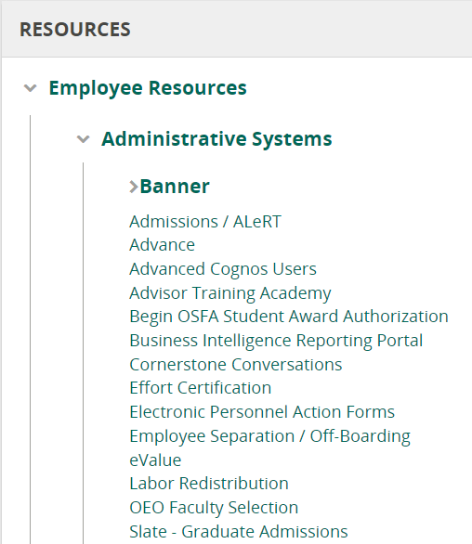
- Select the Advanced Cognos Users link:
The Cognos Welcome Portal is presented.
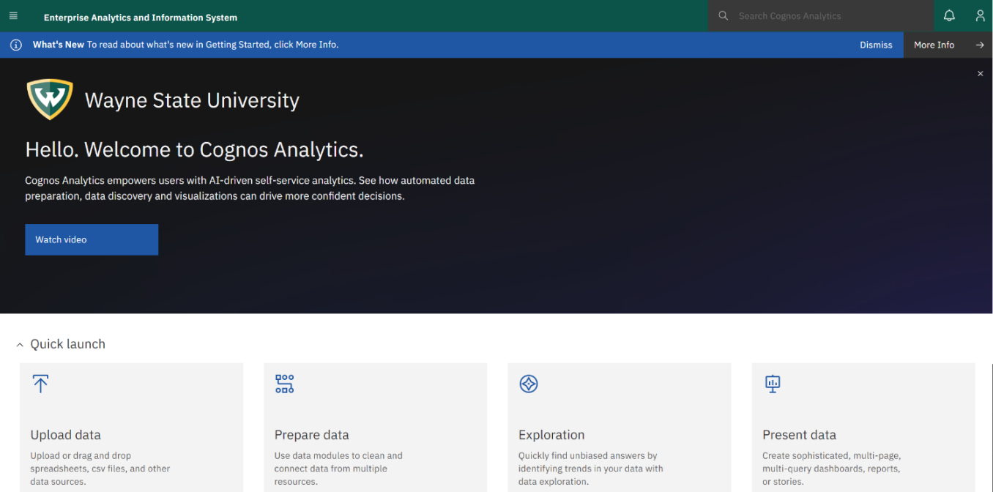

- Select the Business Intelligence Reporting Portal link:
WSU MAIN PORTAL is displayed for Navigation to reports.
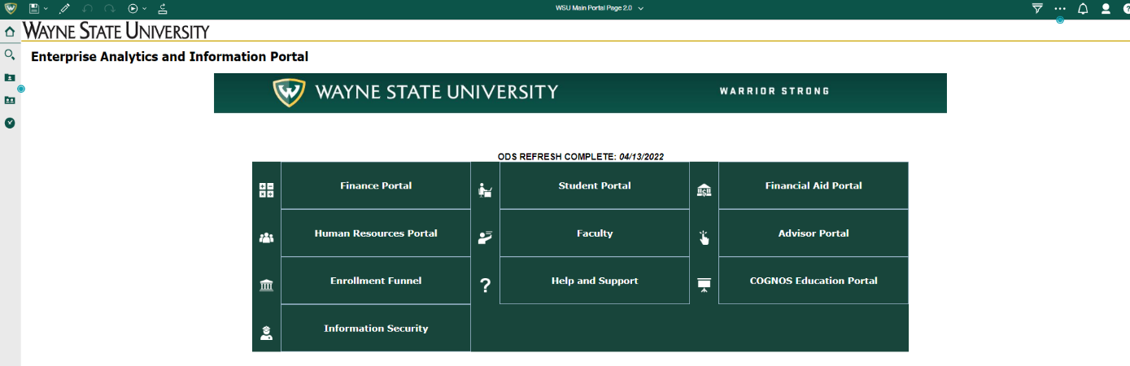

- Access directly via the URL https://ppreporting.ad.wayne.edu/crn Pre-Production Reporting
You will be presented with the official University logon page for Cognos.
Login to Cognos using your Access ID and LDAP password.

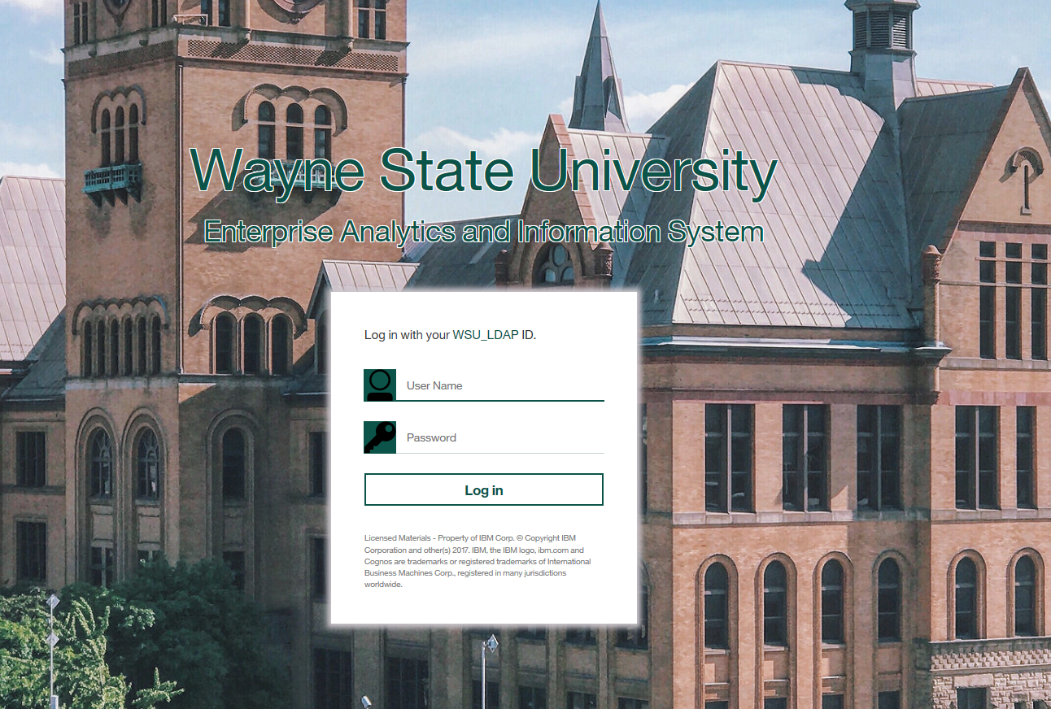

After successful authentication into Cognos, the Cognos Welcome Portal is presented.
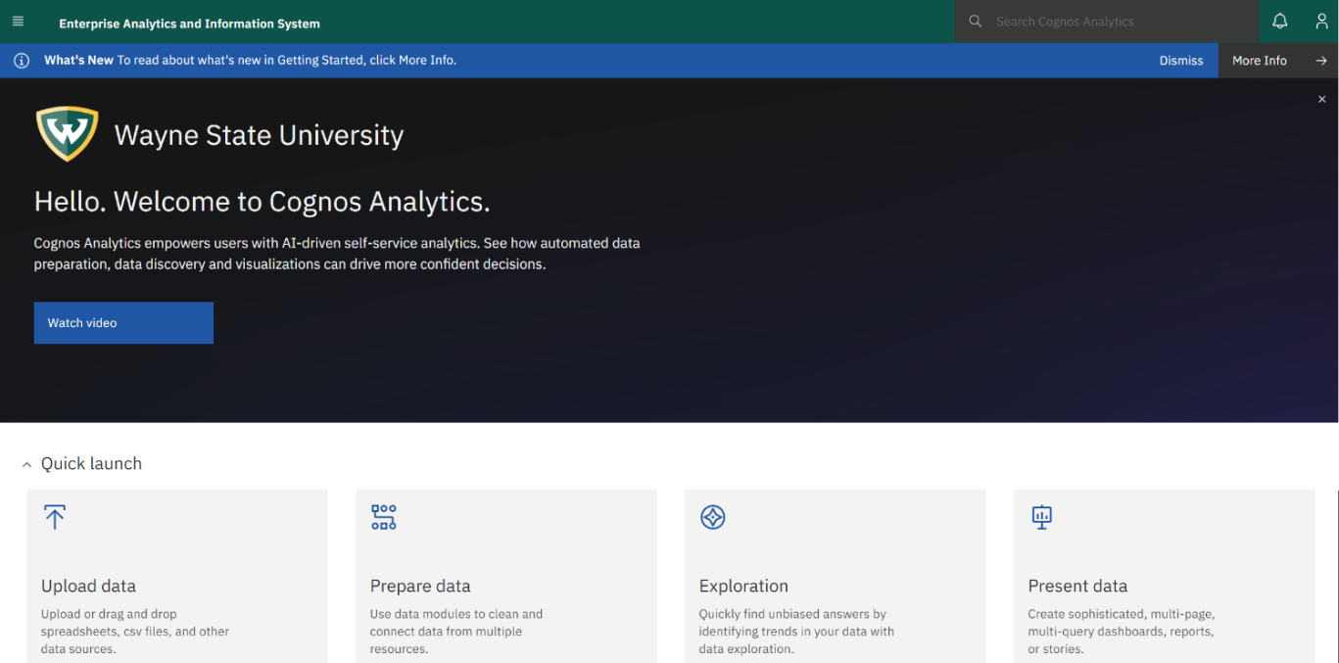

A DEEPER DIVE INTO THE COGNOS WELCOME PORTAL
The default home page in Cognos is the Cognos Welcome Page – but you can set it to a Report or Dashboard instead.
You can access your Home page by clicking the Open Menu icon and selecting the Home option. 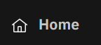
- The Home screen can be set using the Personal Menu in the top right of the page and selecting “Profile and settings” – from anywhere in Cognos

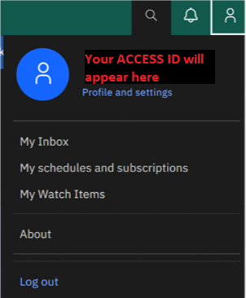

Cognos 11.2 features an application bar, available from anywhere in Cognos, which allows you to search and access existing Content, create new Content, view Notifications, and access the Personal Menu.

The application bar features the Open Menu on the top left which serves as the main access point to Cognos Analytics and contains numerous options:
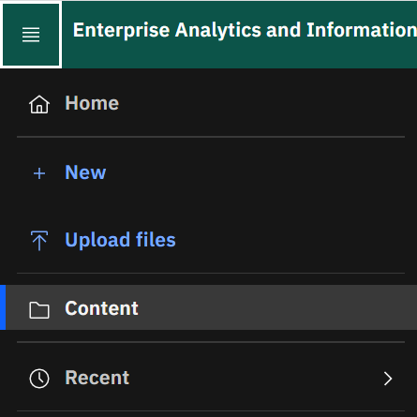

Home will always bring you back to your home screen.

New allows you to create a new Dashboard, Report, Story, or access other applications (privileges here are dependent upon access granted to your role).

Upload files allows you to upload data files to explore using Cognos Analytics (this access is only available to administrators and some report authors).

Content allows you to access Team content, My content, and Recent items.

Recent allows you to access recently viewed content.

GETTING TO YOUR REPORTS
You can access the reports that have been previously created and saved from anywhere in Cognos by clicking the Open Menu and selecting the Content option 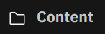. From there you will select the folder that contains your report, either in the Team content (WSU content) or My content (Personal content) area.
You may also access recently viewed reports in the Welcome Portal under the Recent tab.

SEARCH
Another way to find and access previously created content is through Search. Search is available from anywhere in Cognos in the Application bar.
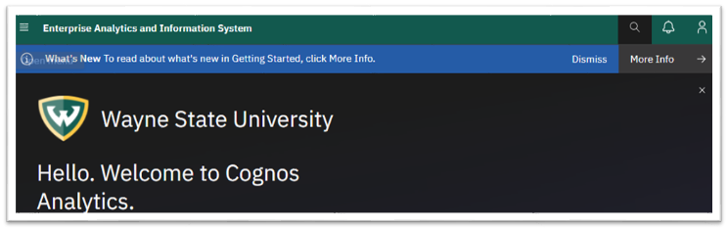
To search for reports:
- Click on the search icon 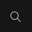
- Begin typing the report name or keyword that you want to search for in the search box. The search engine returns results as you type, similar to the Google search page.
Notes: You may use special characters in your search terms. Search terms enclosed in double quotation marks (“ “) return results where those terms appear in that exact order.

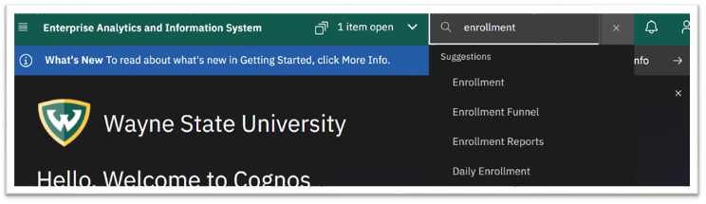
- After you type your search criteria (and press the Enter key or select search criteria from the dropdown), a list of results will open on a new page.
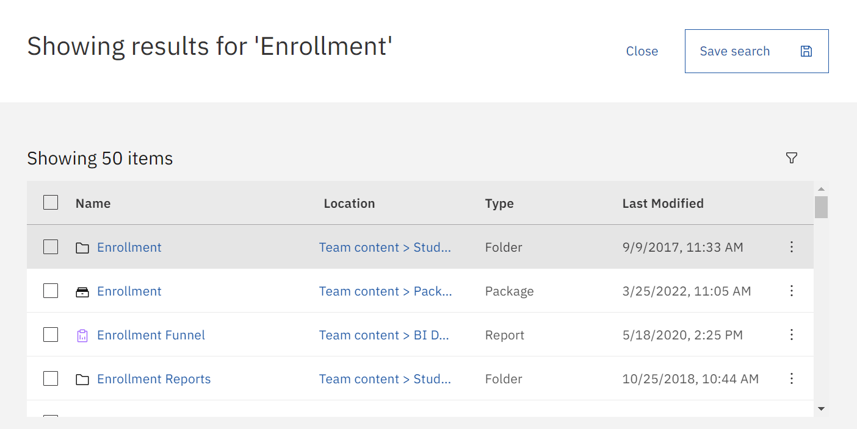

- After the results are returned, you may save your search for future use by clicking Save Search.
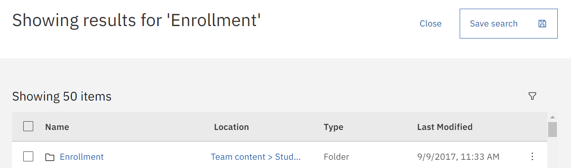

- Select the Filter icon to Narrow your search.

- You can narrow results by content type or by last modified.
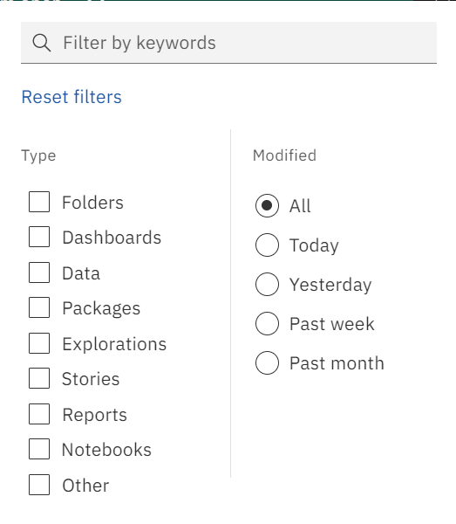

Note: there is an icon in the front of the object name that, when moused over, tells you what type of object it is (report, report view, dashboard).

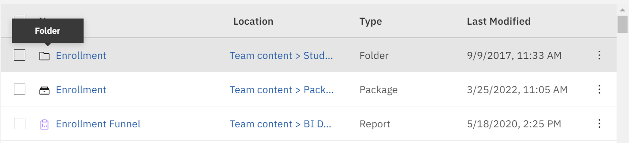

The ellipsis by each entry allows for quick actions to be taken on the individual object.
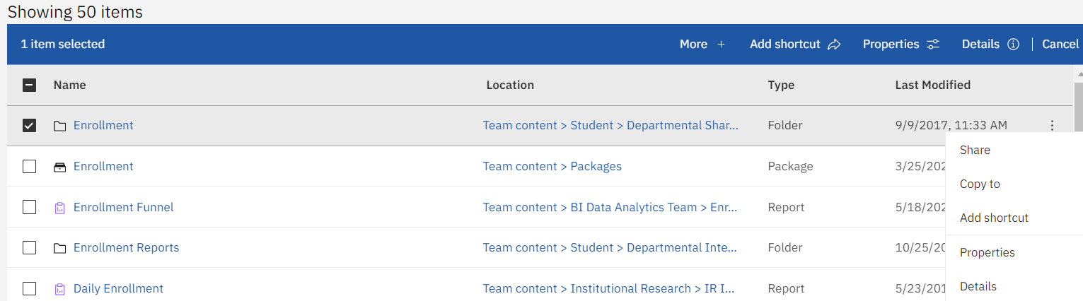

TEAM CONTENT
After accessing the Content area 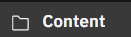 and selecting the Team content tab, you will see WSU’s content. This is where you find reports, packages, dashboards, stories, models, and more. Items in Team content are organized in folders. These are generally grouped by business area or function.

Note: This will look different for everyone as it is your role and access that will dicate which Team folders you can see and access.

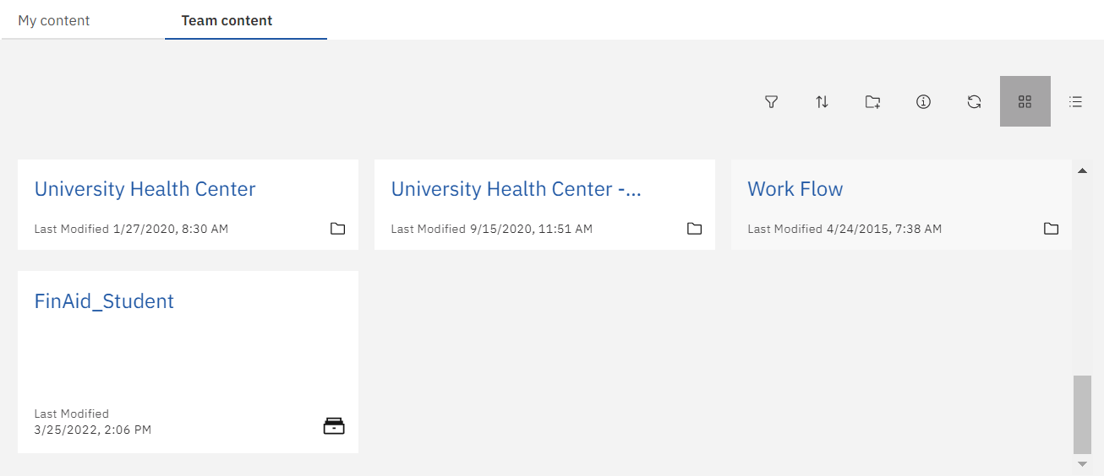

MY CONTENT
After accessing the Content area and selecting the My content tab, you will see the My content area. This is where you will find your personalized reports.

The folders here allow you to customize, organize and save reports specific to you. Think of this area as your “playground” – for reports specific to your needs and accessible by only you.

The toolbar at the top of the page includes a folder icon which allows you to add new folders to further organize your reports. Hovering over each tool will tell you what that option does.
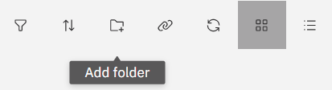

Note: This will look different for everyone as this is your own personal work area.

RECENT REPORTS
Recent content can be accessed from the Welcome Page and Open Menu.

From the Welcome Page, select the Recent tab to view recent content.
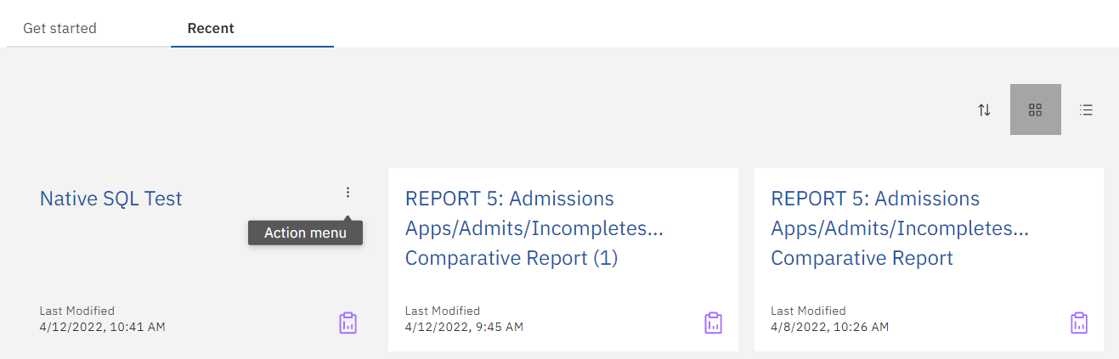

When you hover over an object, an ellipsis appears in the upper right corner of the object pane. Clicking on the ellipsis will show quick actions you can take on that object as shown below.

Note: The actions you can take will be limited to the Cognos role assigned to you. For example, Consumers are not able to edit reports.

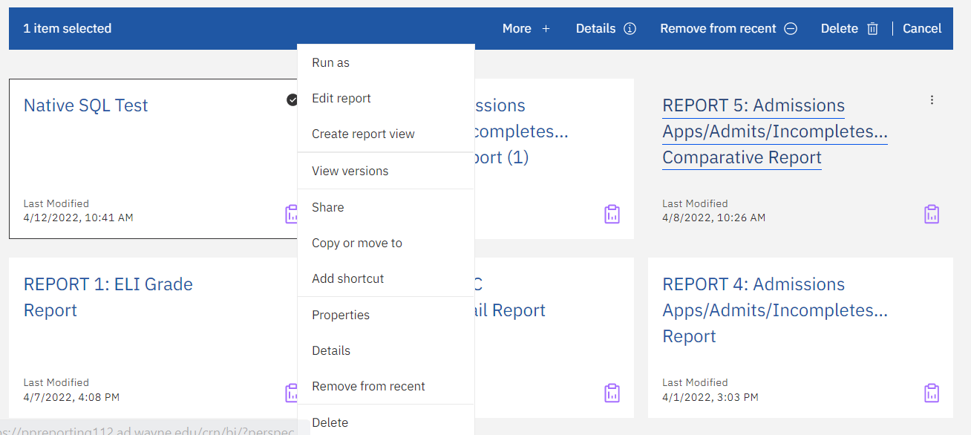

From the Open Menu, the Recent icon will present a slide out pane that shows a list of the most recently viewed objects. Click the object to open it.

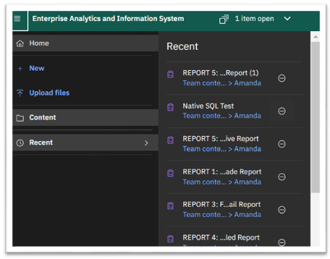

RUNNING REPORTS
There are many ways to run reports in Cognos. Below are some examples.

- Click on the report name. This is a hyperlink that will automatically run your report.
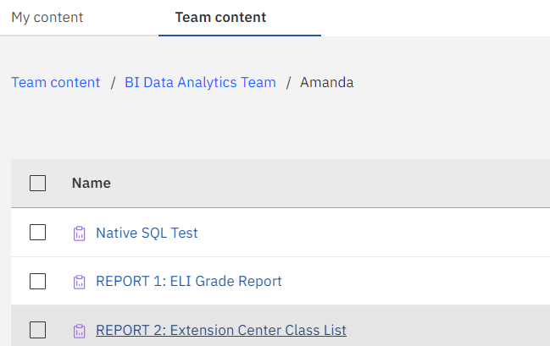

- Right click on the report name and options will be presented for you to Run as
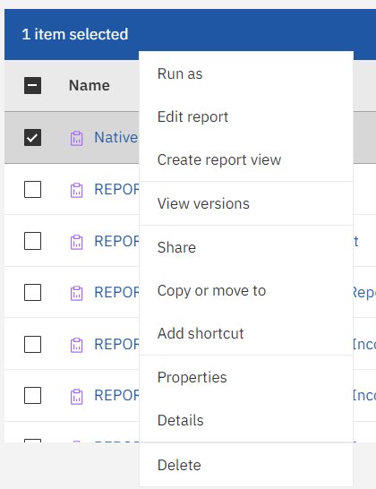

- Use the ellipsis next to the report name and select the Run as option.

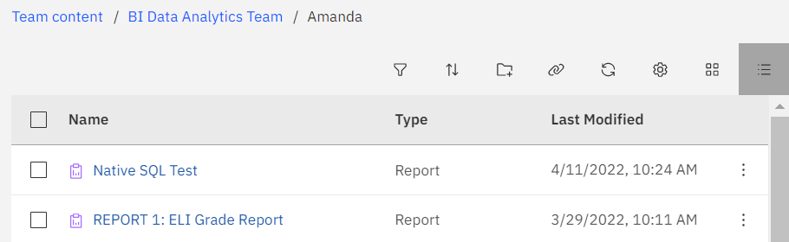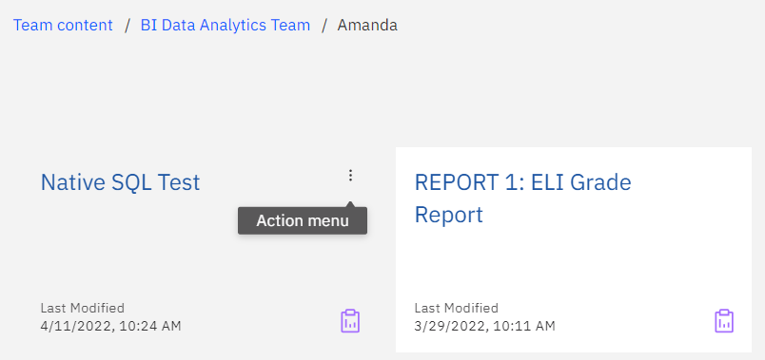

The Run as option will present you with options to Run in background, allow for prompting, and select the output format before actually running the selected report.
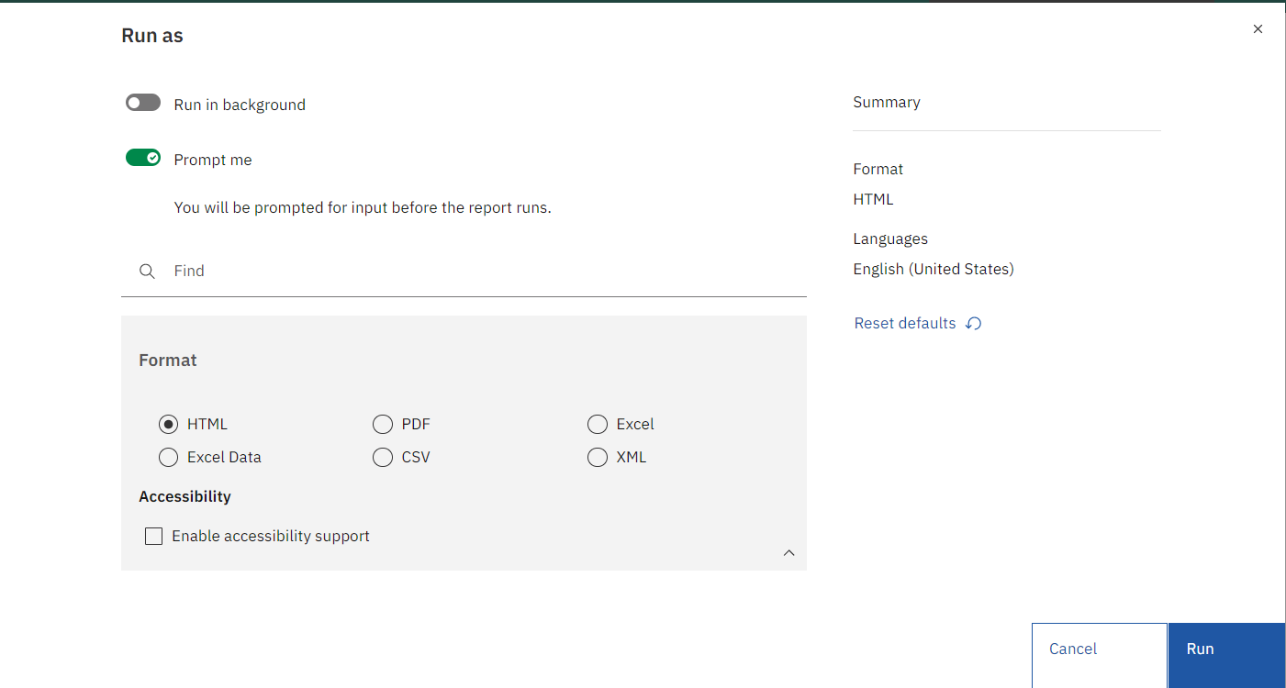
Whichever method you use to run your report, if your report has prompts, the prompt page will be presented for you to choose the parameters to use in generating the report.

Required prompts will be flagged with a red asterisk and the finish button will be inaccessible until a selection is made.

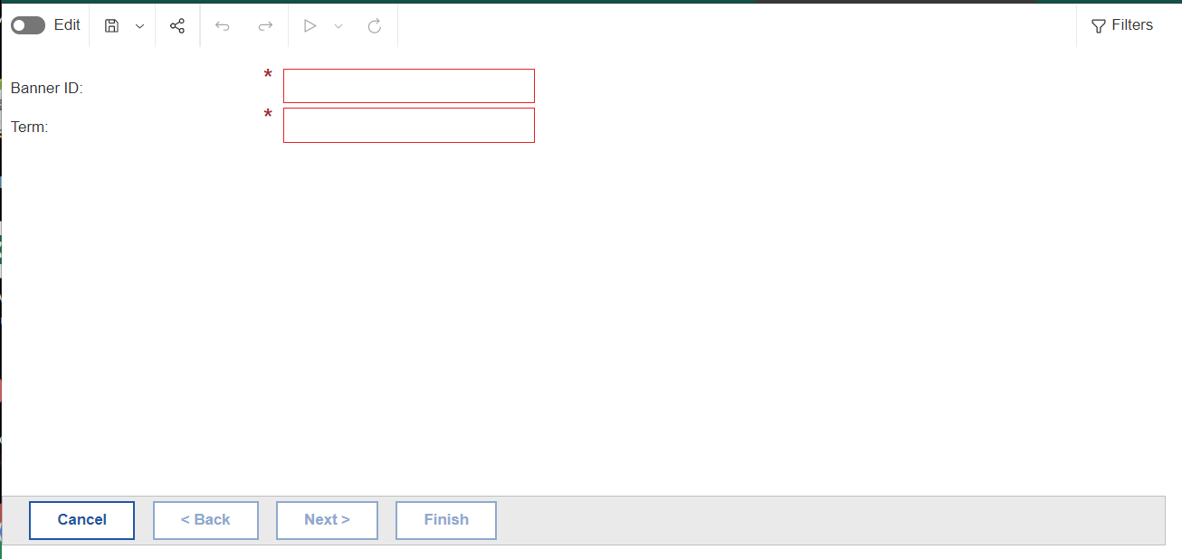

Once the prompts are selected, you can run the report by clicking the finish button
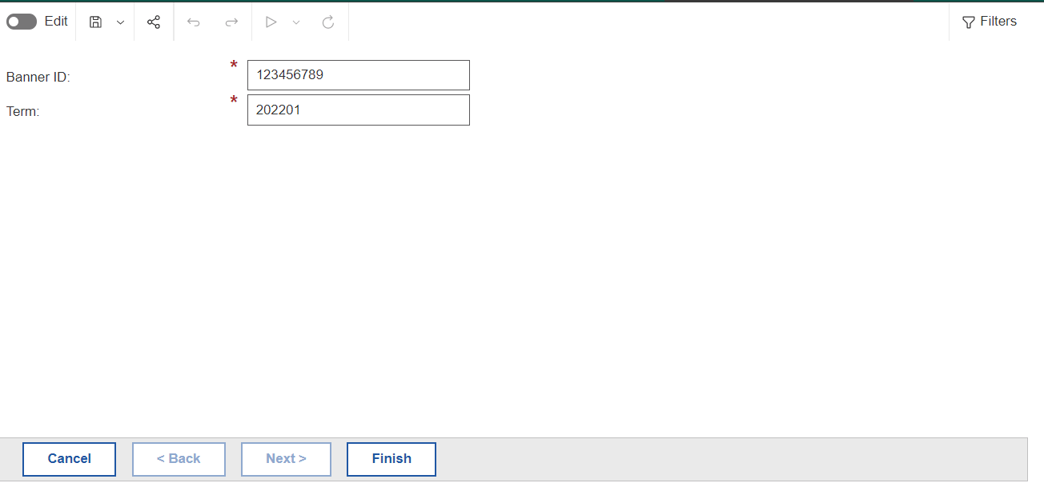
The report will be generated and displayed if html format is selected.
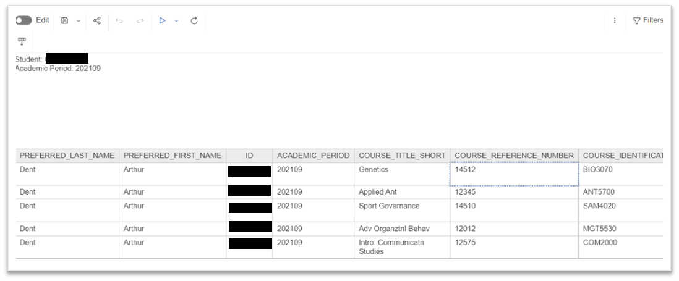

- HELPFUL HINTS:
Re-Run - you don't have to close out of your report to re-run it. Depending on your report, you may be able to re-run the report with one of the following methods.

Select the Run As icon 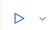and then choose “Reset prompts and run”. You will be taken back to the prompt page where you can select new values. (Note: The previously selected prompts are retained).
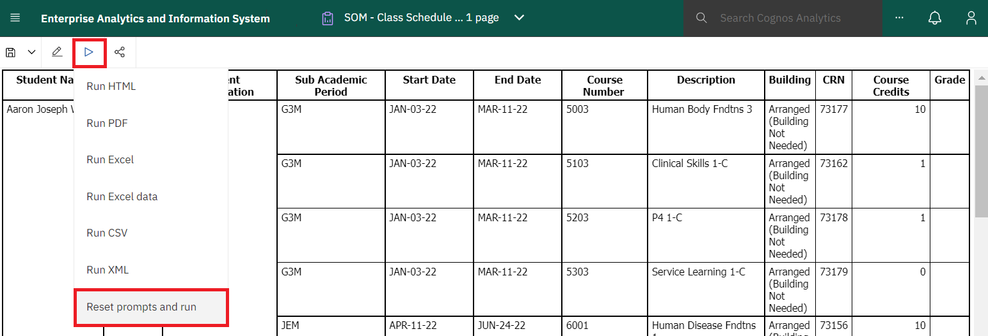
Select the ellipsis in the upper right corner and choose Clear parameter values. Then click the Run 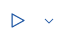button. You will return to the prompt page and may run the report again with new values. (Note: The previously selected prompts are not retained).

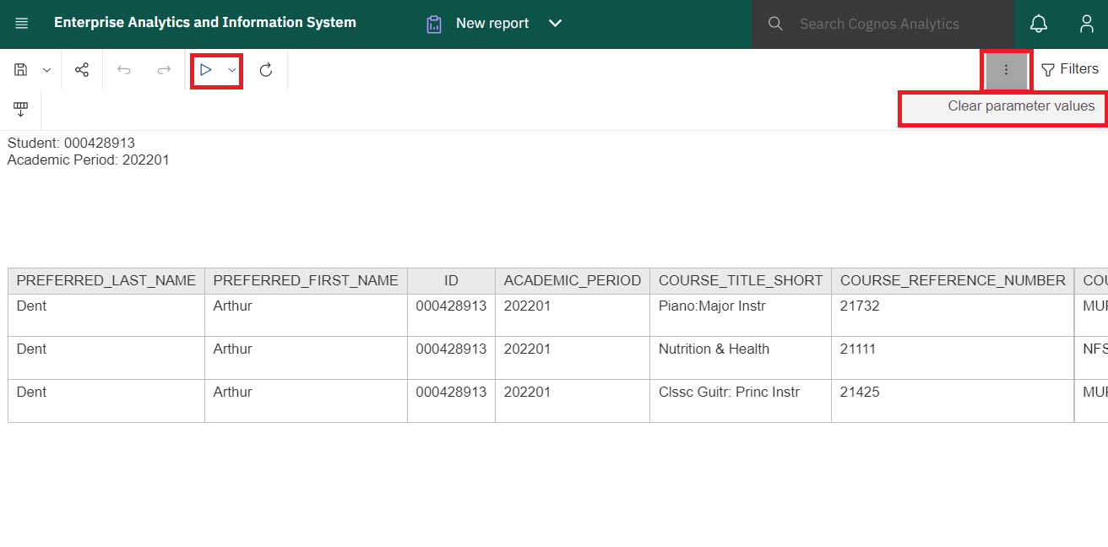
Change Format - After you run your report, you can view it in different formats including Excel and PDF.
This is done by clicking the Run As icon and choosing from the various output options in the list.
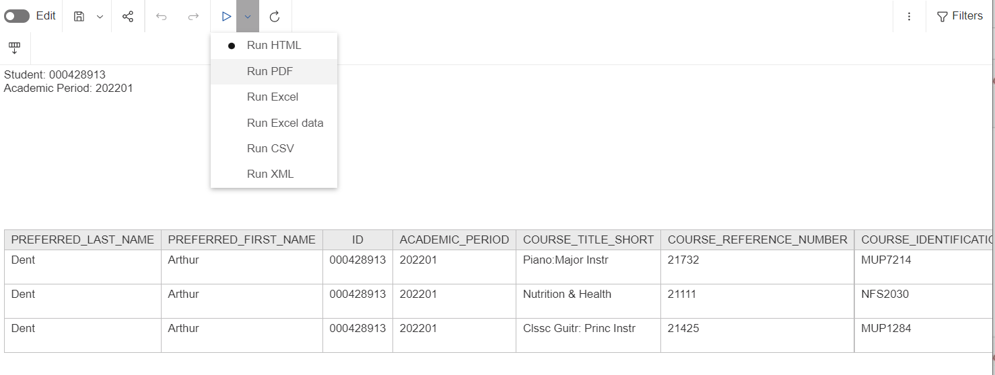

CREATE REPORT VIEWS
A report view is a reference to a report. The report view shares the same report specification as the source report but has different properties such as prompt values, run options, schedules, delivery methods, languages, and output formats. A report view is different from a copy as a copy of a report is an independent version of the original report.

Creating a report view does not change the original report. You can determine the source report for a report view by viewing its properties. The report views properties also provide a link to the properties of the source report.

If the source report is moved to another location, the report view link is not broken. If the source report is changed, those changes will appear in the report view and the link is not broken. If the source report is deleted, the report views icon changes to indicate a broken link and the link to the source report in properties is removed.

Creating a report view enables you to easily locate a report or save entered parameters.

Report views should be saved to your personal space in the My content area.

To create a report view:

- Select the report you wish to create a report view of by right clicking the report name or clicking the ellipsis.
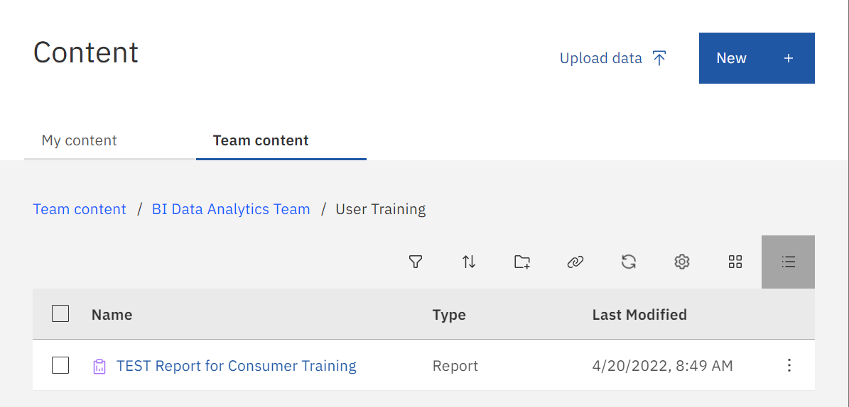

- Select the Create report view option from the list.

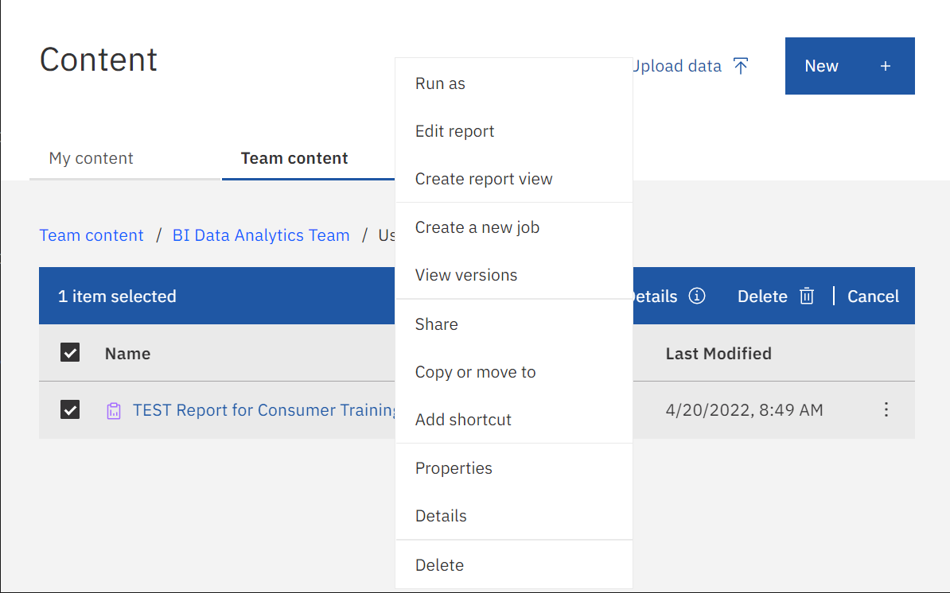

- The “Save As” screen will be presented. Enter a name for your report view. When selecting a name for your report view, we recommend keeping the report ID and name, then add words describing how the report view has been personalized.
- Select the location you would like to save the report view. The best practice is to choose “My content”. Select Save.
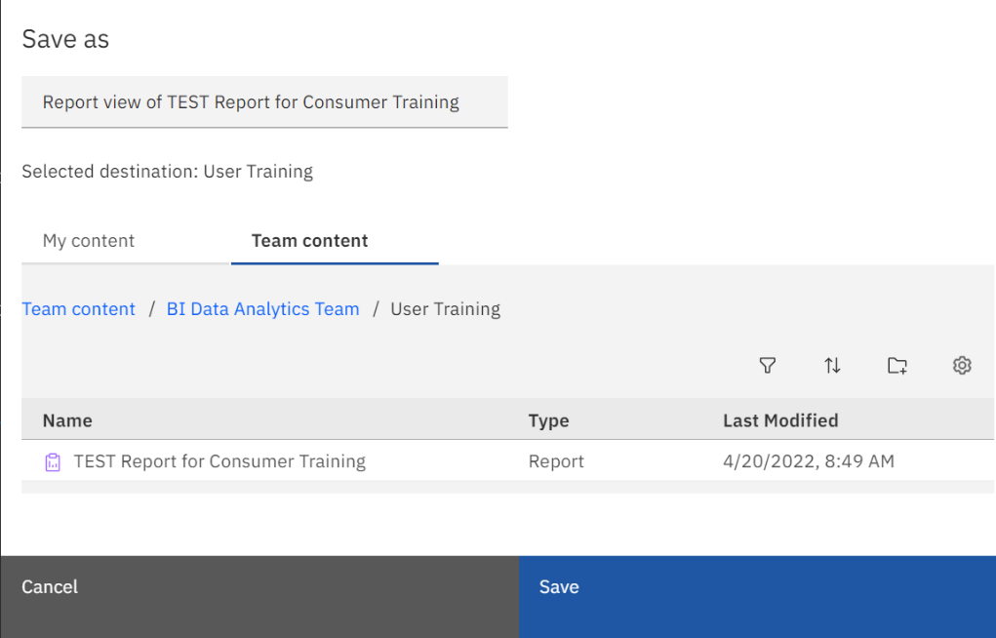
- The report view will now be found under your “My content” area:
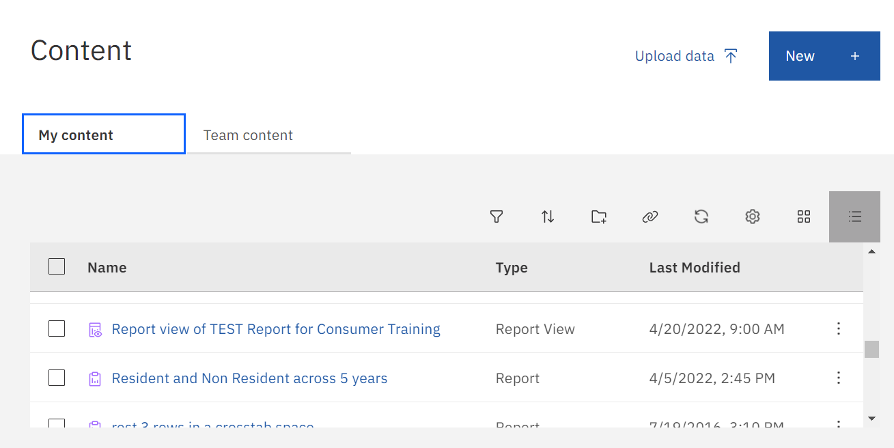

To ensure the report view is presenting new data when the report is run:

- Click on the drop-down arrow under Report options

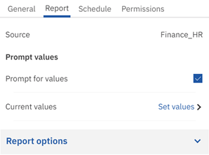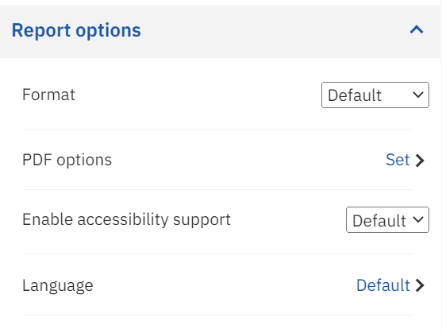

- Under the Advanced drop down, change the Default Portal Action to Run the Report.
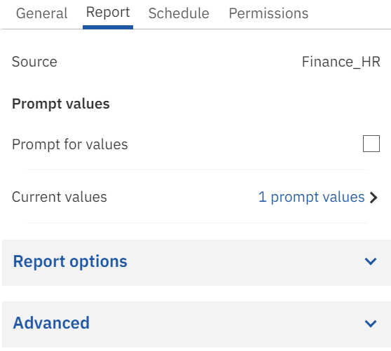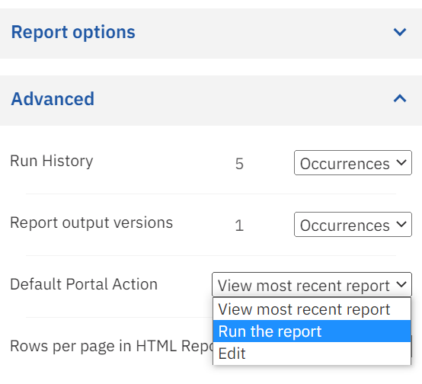

The report view can be customized by saving your specific parameters. To personalize the report view:

- Right click on the report view name or use the ellipsis to see the options list. Select Properties.

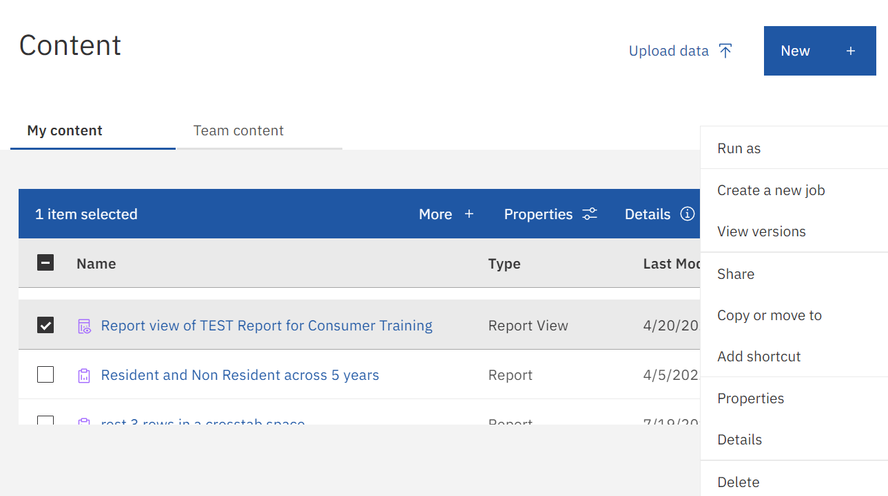

- Click on the Report tab.

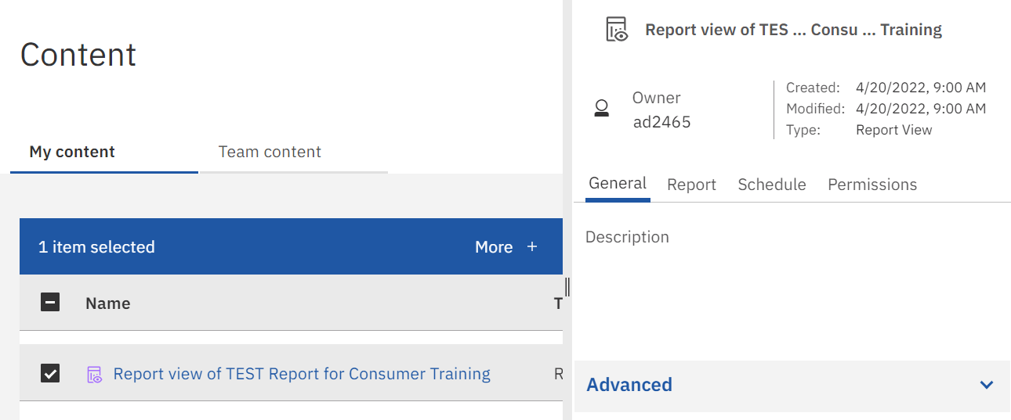

- Under the Prompt values section, leave the Prompt for values checkbox unchecked and select Set values to set the parameter prompts.

- Choose the Set option to set the Current values.

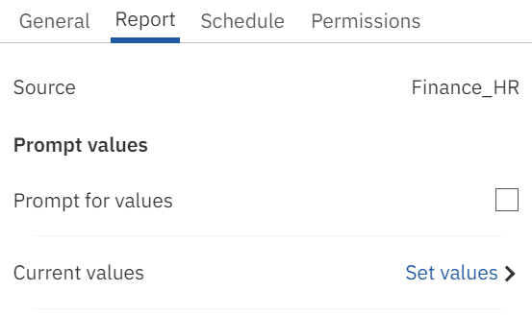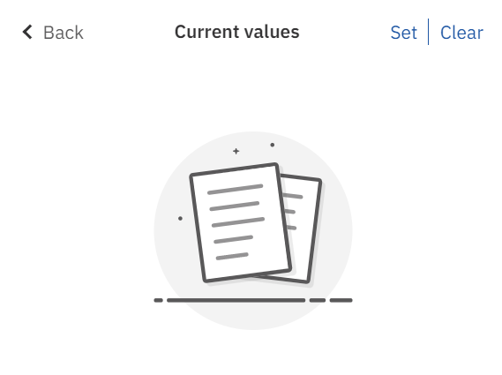

- You will be presented with the report’s parameter page. Select the Parameter values you want to run the report view with and click Finish.

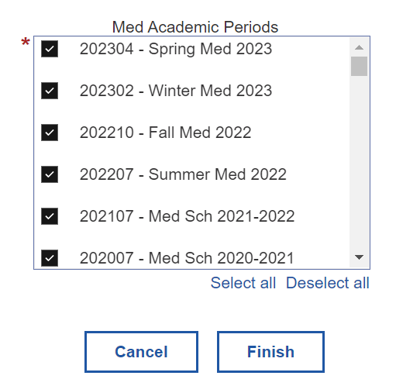

- Note the prompt values you set are now displayed.
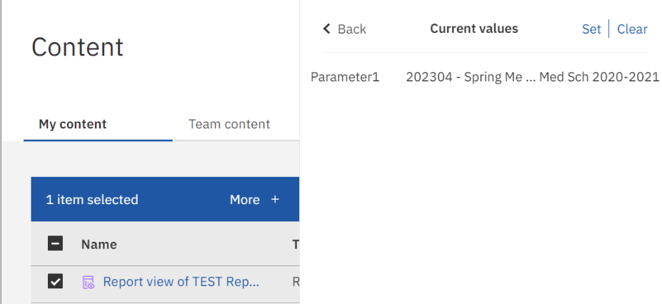
- The parameter values you entered are now saved to the report view. Each time you run this report view, the values you set will be used. You will not be prompted to change the parameters each time.

To run the report view using different parameter values each time the report view is run:

- Select Run as from Action Menu by clicking the ellipsis or right clicking on the title of the Report View.
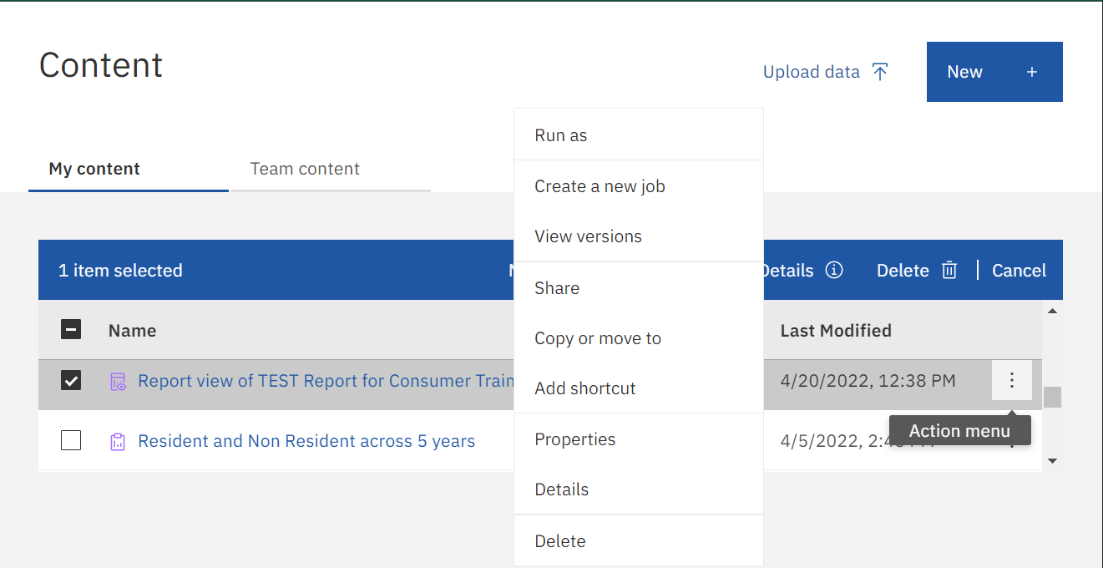

- Turn on the Prompt me radio button, then click Run to execute the Report View and the parameter page will appear. You can also change the Format by selecting the desired format in the Run As options.
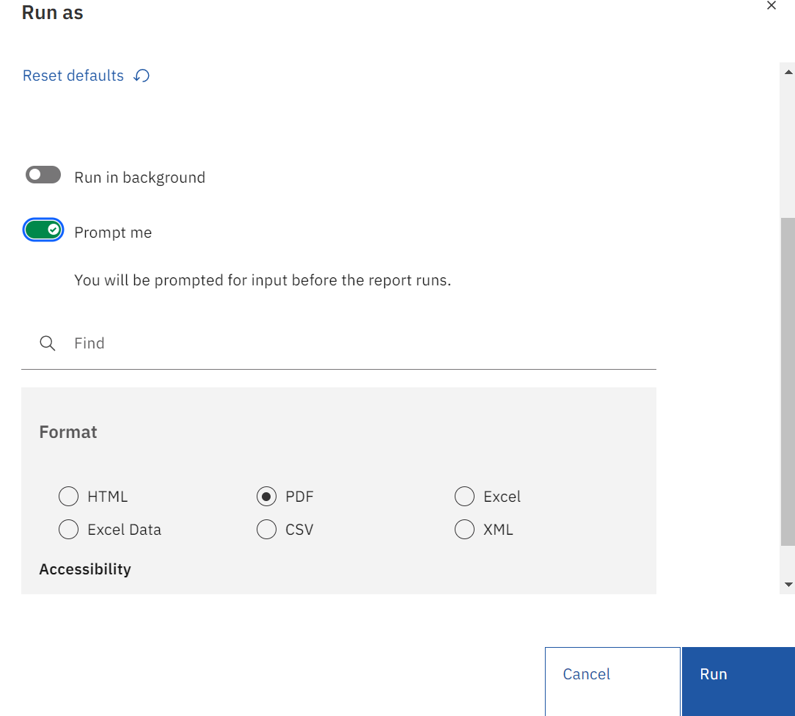

- Your saved parameter values are still set and will be displayed on the parameter page. Remove any pre-filled parameter values. Select the desired parameter values and click Finish to execute the report.
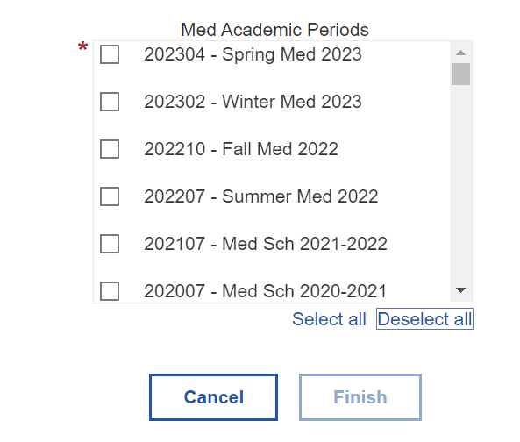

SUBSCRIBING AND SCHEDULING REPORTS

For reports that a user runs regularly, Cognos includes features to automatically run and deliver the report with your prompt values and options at a specified time interval. Report owners can Schedule a report, while any user is able to Subscribe to a report.

Subscribing to a report allows a user to pick the time, date, format, and where it should be delivered.

In this example, we will Subscribe to a Cognos Report.

To subscribe to a report:
- Run a report as normal. Click the ellipsis in the top right of the application bar and click Subscribe.
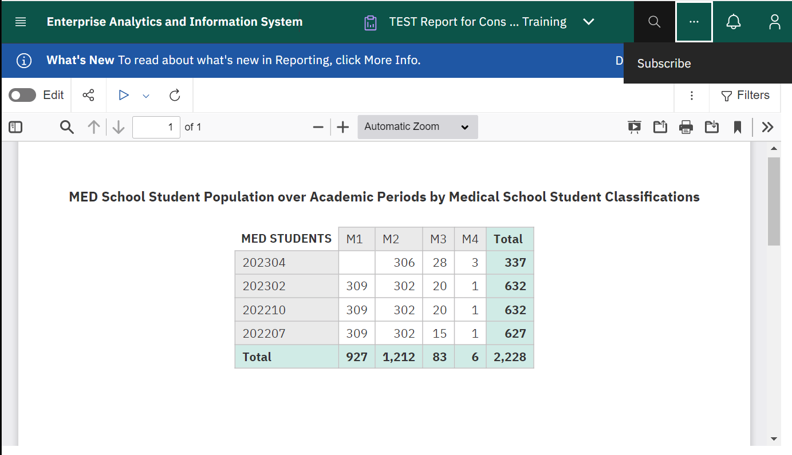

- The Subscribe menu will appear. You can set day, time, format and delivery options in this Menu.
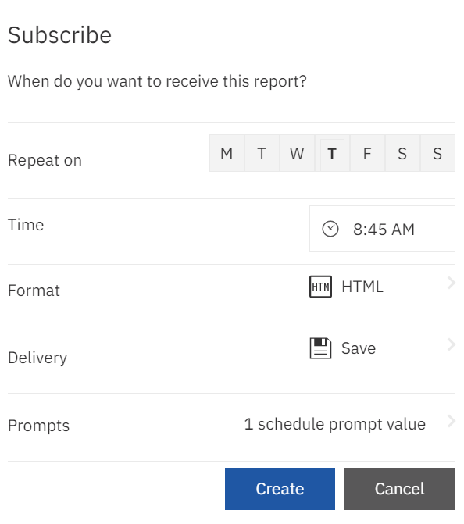

- Select the days of the week you would like the report to run.
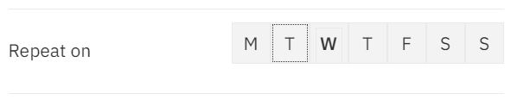

- Select the time of day you would like the report to run.
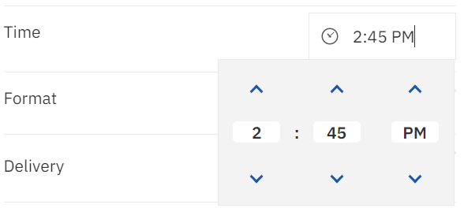
- Click the Format to open the Format Settings pane. Select the desired Format for the report output and click Done.
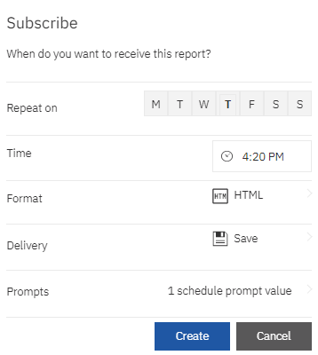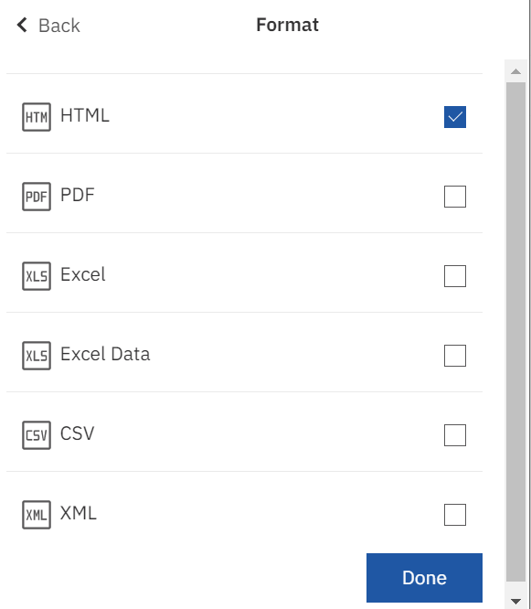

- Click the delivery method to open the Delivery Settings pane. Select the desired delivery method for the report and click Done.

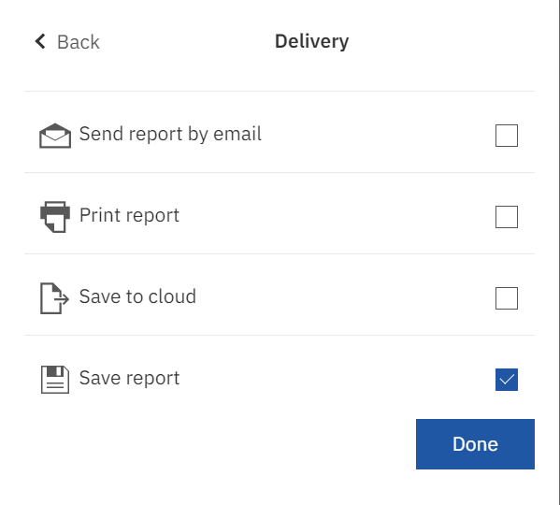

- When the report finishes running at the scheduled time, a red circle appears on the Notifications icon 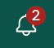. Click this icon to view notifications and a link to the output of the scheduled report.

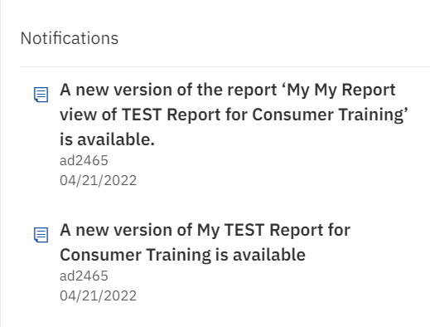

Scheduling a report gives the report owner flexibility to run the report when it is convenient for them or when demands on the system are low. Each Cognos entry can have only one schedule. If you require multiple schedules for an entry, create a report view and then create a schedule for each view.

To Schedule a report:

- Find the Report you would like to schedule.
- Right click or use the ellipsis on the report and select the Properties option. From here you can select the Schedule tab.
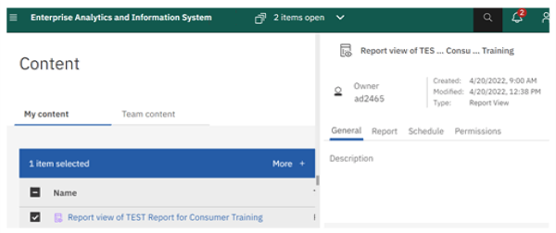

- Click the Create schedule button to create a new schedule.
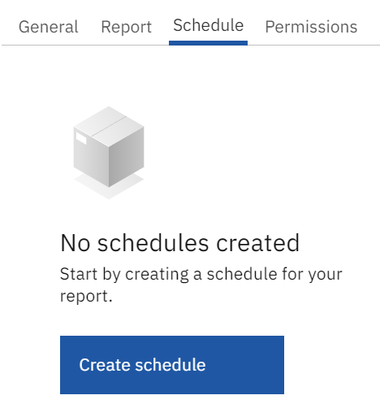

- You will be presented with the Create schedule page. You can pick the Schedule, Options (Format & Delivery) and Prompts.

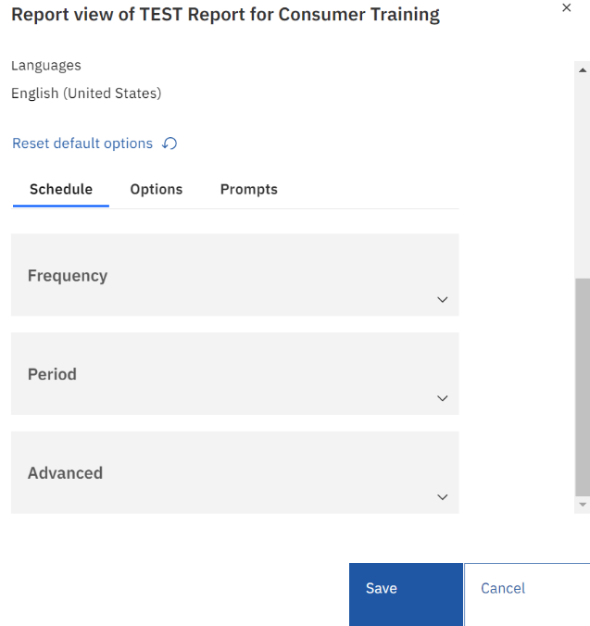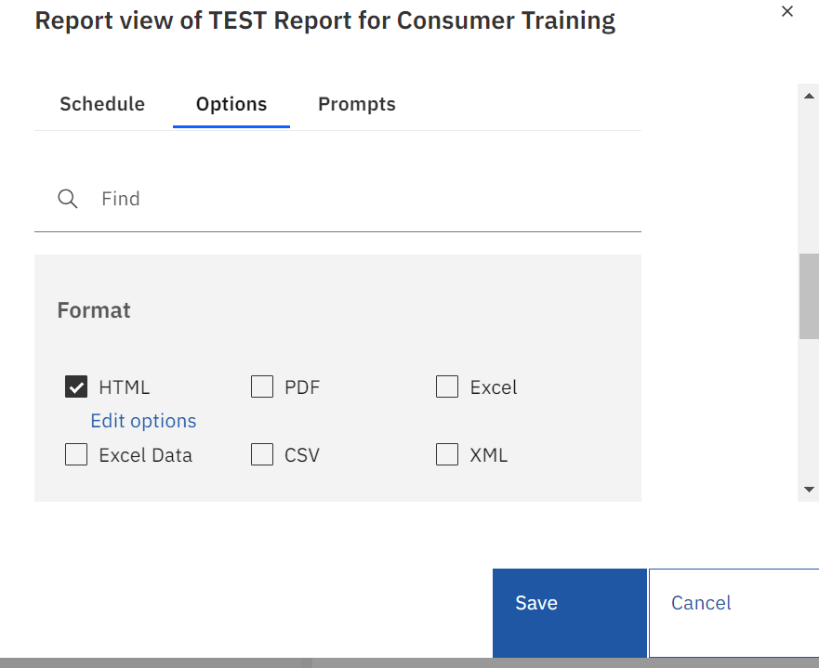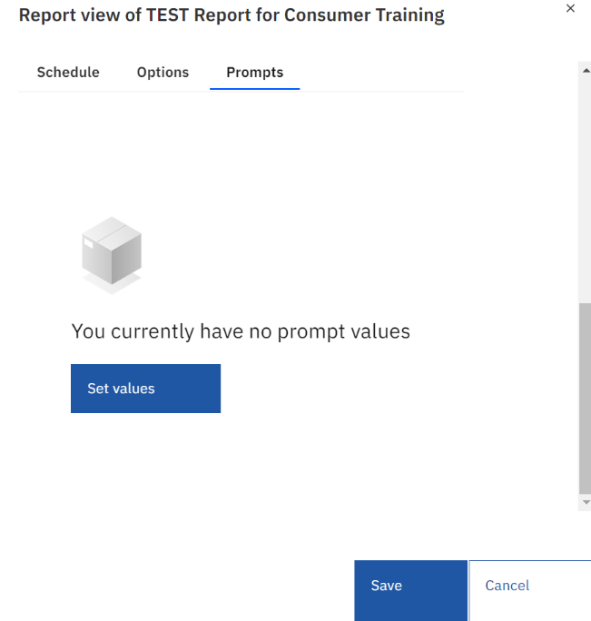

- To pick the delivery method, click on the desired Delivery option and choose if you want to save the report (default) or send the report by email.
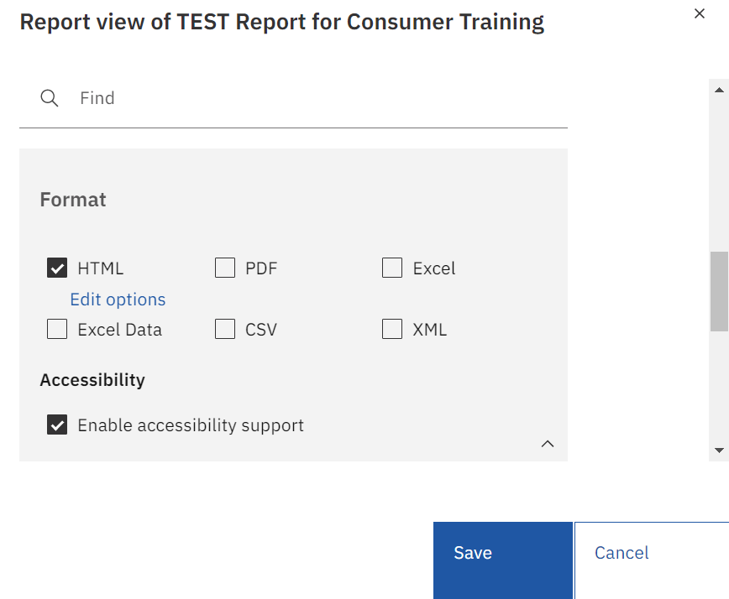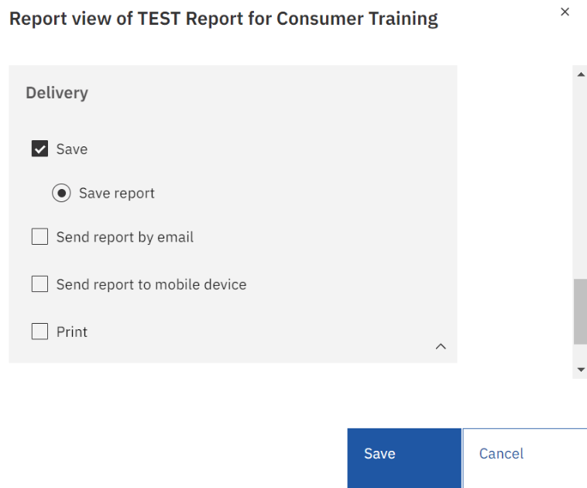
- To send the report by email, click the checkbox.
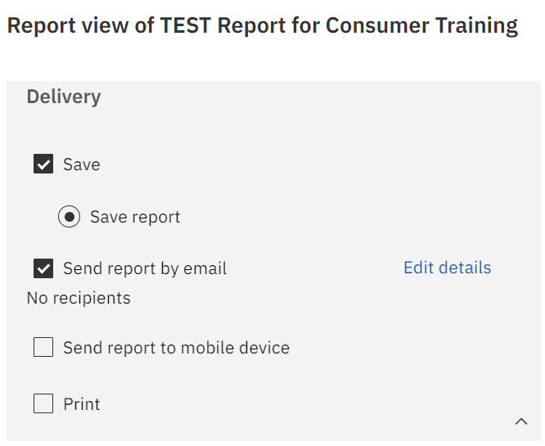

- A window will expand below that allows you to enter the options for the emailing request.
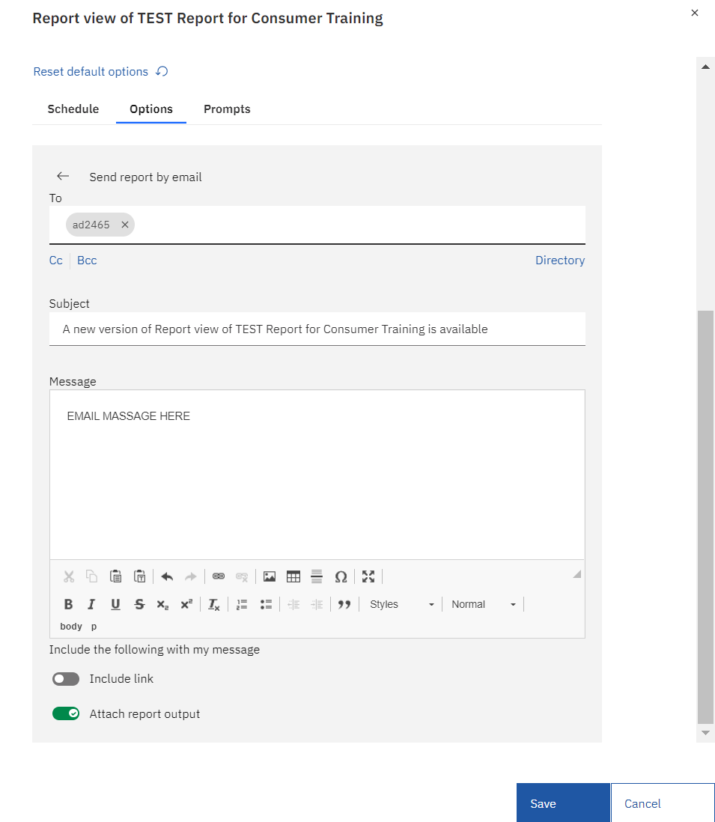

- You can manually enter email addresses or click on the arrow next to the TO and select email addresses.
- The subject line is pre-populated with the report name but can be altered.
- You can choose the Include a link to the report option by leaving that check box clicked. However, doing so will force the recipient to log into Cognos to view the output.
- You can attach the report by clicking the Attach the report checkbox which will allow the report output to be attached directly into the email notification.
- Click Save to create the schedule.

- You can Disable the schedule by turning the radio button off. Disabling it turns the schedule off but allows it to remain for future use.
- You can also permanently delete the schedule by clicking the Delete icon.
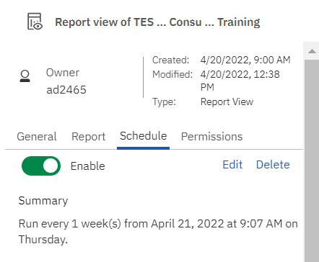

SCHEDULE MANAGEMENT

You may view and manage your scheduled reports using the Schedule Management feature. You can see which reports are scheduled and make changes to scheduled reports.
- Click on the Personal Menu icon in the application bar at the top right of the page.
- Select the My schedules and subscriptions.
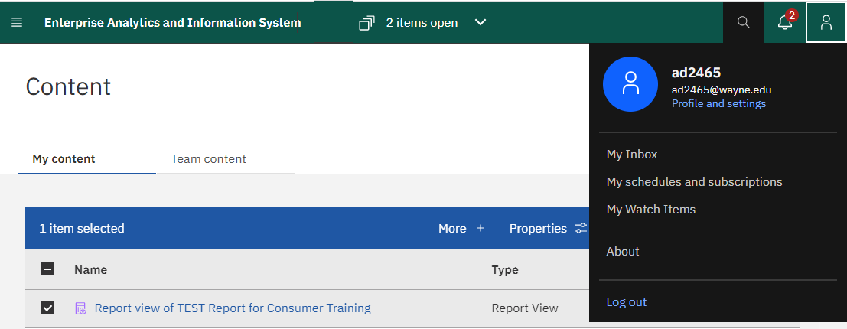

- The My schedules and subscriptions page will show details about your scheduled items, including date modified (date last executed), scheduled by, status and priority.
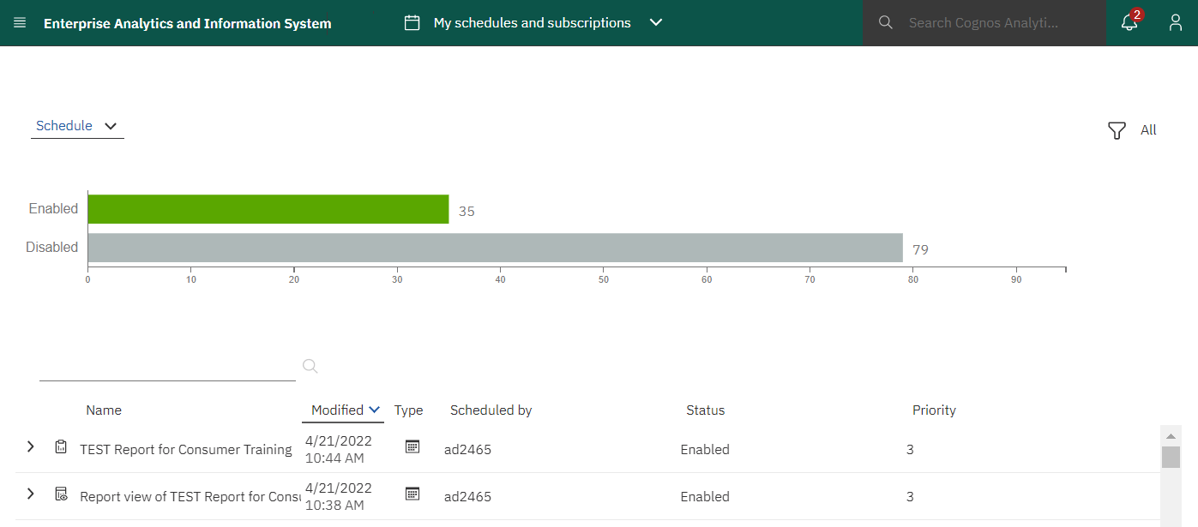

- If you don’t see the report you’re looking for, examine the filters you have selected under the Filter icon on the right. 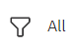Click any filter options that you wish to change and click Apply to show the filtered results.
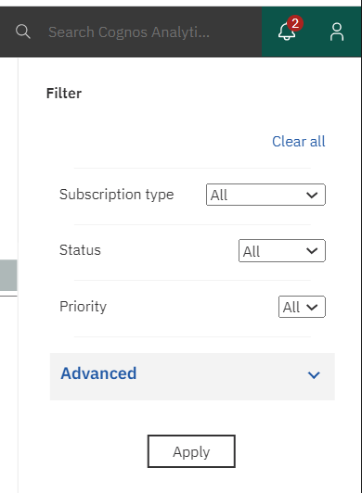
- To perform an action on an individual entry, click the ellipsis next to the scheduled item allowing you now to set properties, modify the schedule, and enable schedule and remove it.

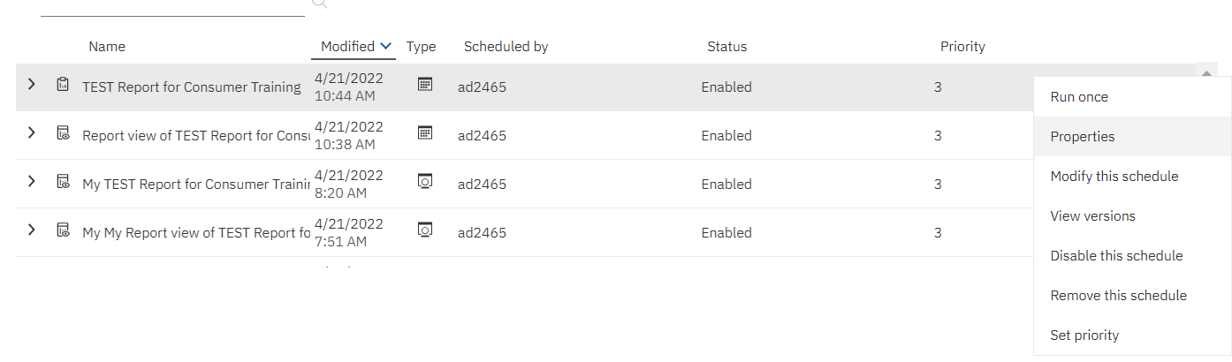

NAVIGATING WSU MAIN Business Intelligence PORTAL

To access the BI portal log into ACADEMICA and select Business and Intelligence Reporting Portal

This is the WSU MAIN PORTAL page. It contains links to various functions, reports, and report lists. Most information is defined by business areas (Finance, Student, etc.). Also included is the status of the ODS and your security information. The data in the portal is secured by the various profiles. You will only see data you are permitted to see.
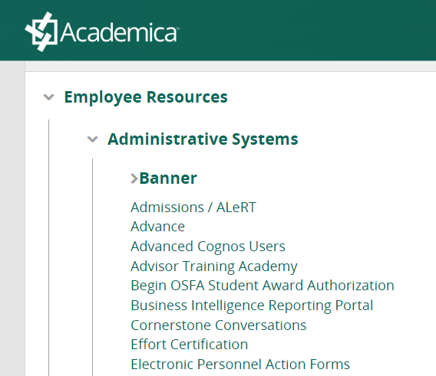

To navigate the WSU MAIN PORTAL
- Select a tile pertaining to your area of interest. In this example, we select the Finance Portal tile.
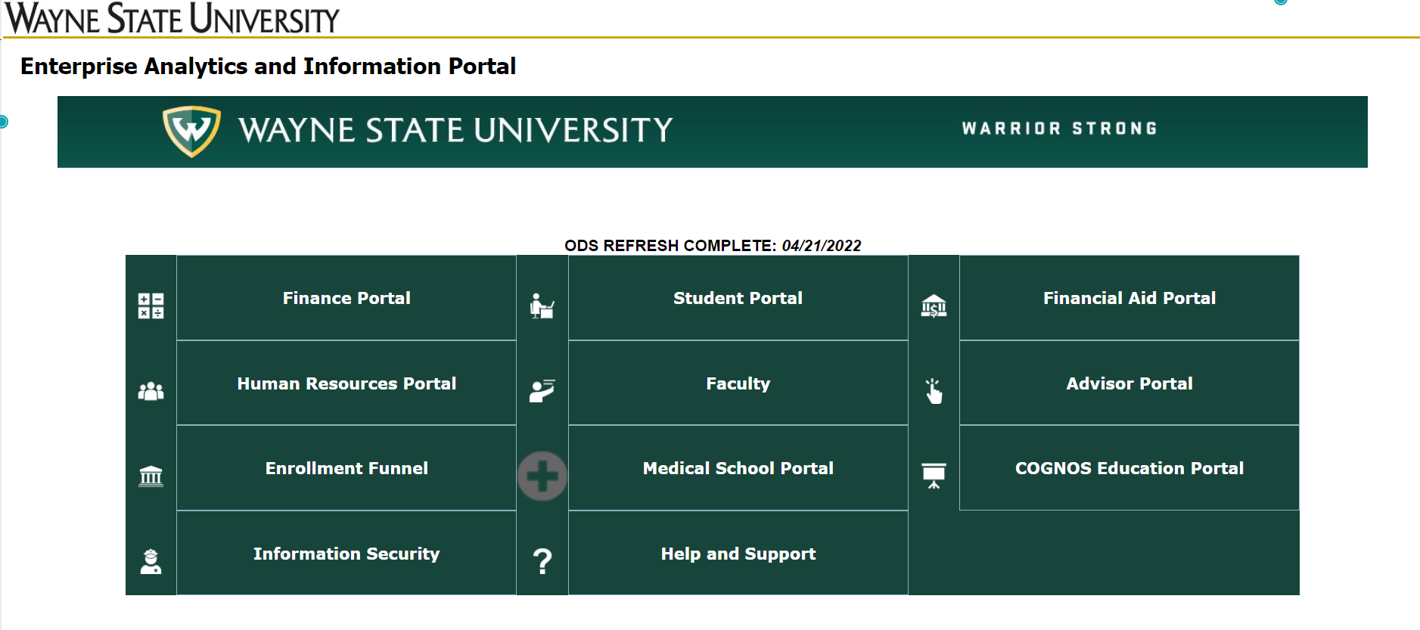
- You will be presented with the portal for the area of interest that you chose. In this example, we see the Financial Portal.
- Select the reports tile for your area of interest. In this example, we select the Finance Reports tile.
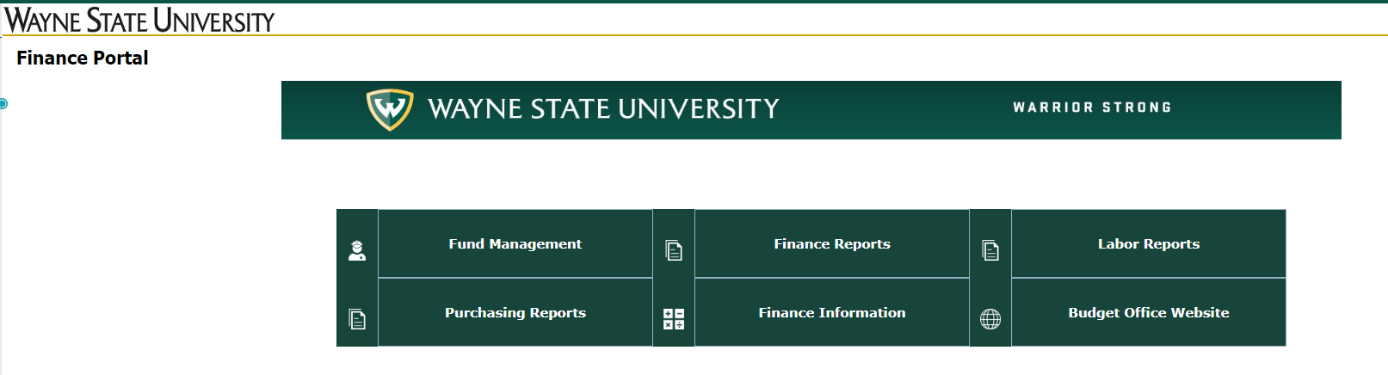

You will be presented with a list of the most commonly run reports and their Business Purpose. You can run the reports by clicking the button in the Submit column. This will take you to the prompt page of the report.
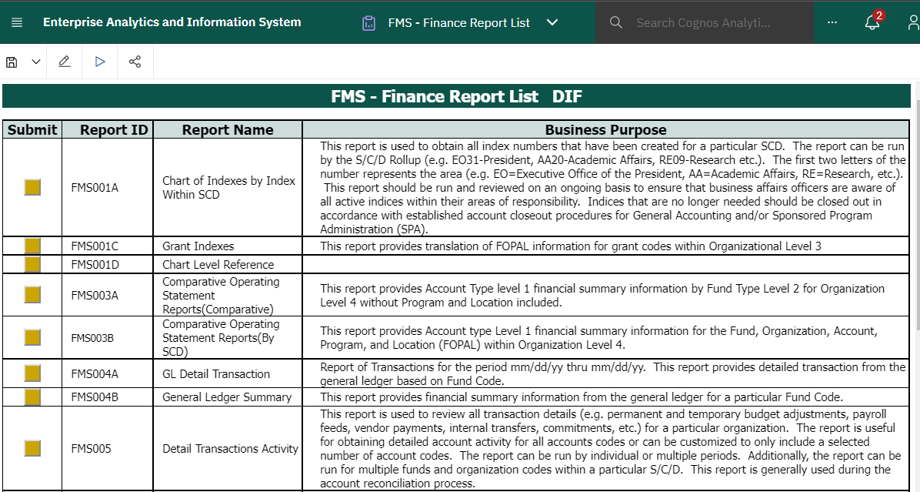
Important note: When your windows/LDAP password is changed or reset, it is not automatically renewed in Cognos. This can cause problems with automatic report delivery as well as other issues.
To correct the issue please “Renew Your Credentials” in Cognos by following these steps:

Click on the Personal menu icon. Then click on the Profile and Setting to update your My Credentials
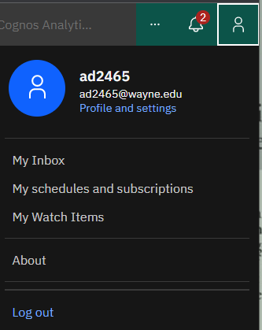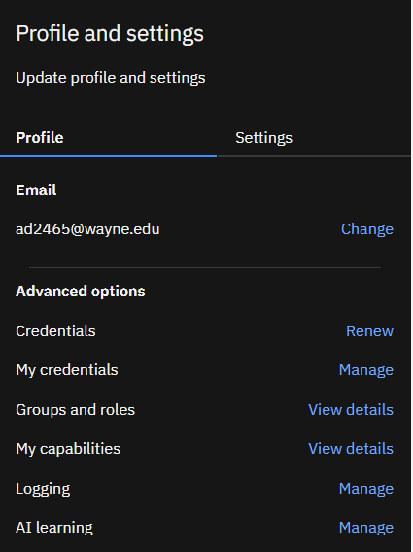
Click on Credentials Renew. You will see a notice that your credentials have been renewed with your current ID and Password.
